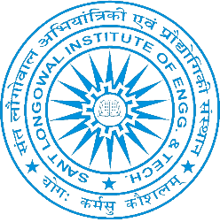We Team Mavericks, Robotics team of SLIET, focusing to tackle the real-life problems with an automated approach. We are bunch of ordinary people thriving to create wonders with our actions. The team is on the mission for hunting emerging talent and robotics enthusiasts from SLIET**.**

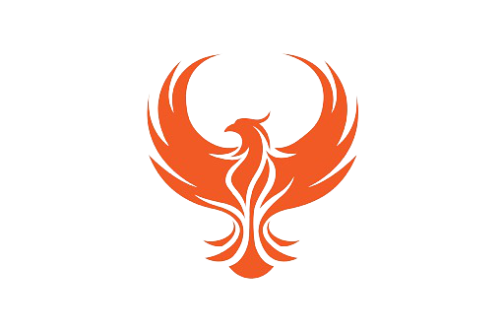**OUR ACHIEVMENTS**

* Our one of the team won in **SIH (Smart India Hackathon, 2020).**
* Two of our team have qualified for Zonal Rounds of **DRDO’s Unmanned Vehicle Challenge.**
* We were also among the top teams of the **E-yantra, 2017**, competition organized by MHRD in accordance with IIT, Bombay.
* We have spread our glories at various technical fests including **IIT Bombay, IIT Kanpur, IIT Delhi, IIT BHU, IIT Ropar, PEC, Thapar University** and many more.

In our team, we provide guidance for developing skills in various **coding platforms**, **development boards**, **circuit designing,** **3D designing software, hardware implementation** and latest technologies. We also encourage our team members to develop various major and minor projects, software related projects, etc. For increasing your skills in different way and not to be ordinary in technical skills come and JOIN US.

Please note that the funding of the projects is solely done by Team members or through the College. Interested **ICD and UG** students can register themselves through the link, by scanning the QR code given below or by visiting our social media handles.

The recruitment process will be consisting of two stages: **Assessment Test** and **Personal Interview**.

**Note-** **All recruitment-related information shall take place through the Email ID and WhatsApp no. provided by you. Must assure that your contact details is correct.**

**The Last date to fill the form is 29th November 2022.**

**Apply now-** [**https://forms.gle/NAND1RgnfSRiuLXJ7**](https://forms.gle/NAND1RgnfSRiuLXJ7)

For any queries contact us: -

* Ram Kumar (6203884073)
* 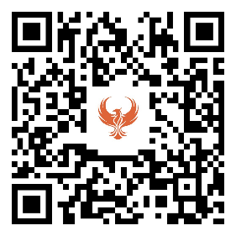Prashant Sharma (8393021054)
* Bhawana Sinha (9060009605)
* Dheeraj Kumar (8218919732) or mail us at: [Mavericks@sliet.ac.in](mailto:Mavericks@sliet.ac.in)

**Faculty Advisor**

**Dr. J.S. Ubhi (ECE)**